Wiki2Logic: Parsing One Piece Text
  - NLP Data Mining Project

Blu LeBlanc
MS-DS Degree Path
University of Colorado Boulder
Lafayette, LA, United States
bluleblanc@gmail.com

ABSTRACT
This project proposal presents an exploratory framework for automatically extracting logic statements from Wikipedia articles relating to a category using natural language processing techniques. For this project iteration, we are processing all Wikipedia articles involving the piece of media known as One Piece. As an incredibly large collaboratively edited encyclopedia, Wikipedia contains millions of articles describing factual relationships. Our proposed project aims to develop an NLP pipeline that identifies, parses, and formalizes logical statements embedded within Wikipedia text from a particular search category into machine-readable forms.
The proposed methodology involves three components: identification and gathering of text based on a category type, extraction of logical components (subjects, predicates, objects) utilizing NLP techniques, and transformation of these logical statements into a knowledge graph visualization. The final output will be a database file containing all of the logic relations gathered and additional information that is used to create a knowledge graph.
After research, we have identified the tools necessary for extracting logic statements and visualizing our results. The goal is to create a pipeline that works with any category; one piece was chosen due to my familiarity with the series and ease in evaluating the accuracy of logic statements generated.
1 Introduction
Wikipedia represents one of humanity’s largest repositories of structured knowledge. Within these articles lies a vast array of logical statements and facts expressed in natural language. This logical knowledge remains trapped in unstructured text and is difficult to query systematically. Our project aims to tackle this task and create a repository of logic statements mined from Wikipedia articles.
After gaining more information and experience dealing with this project, we have come to the conclusion that parsing all of Wikipedia is impossible currently. Not only are the computational resources required too time consuming, but there is also significant difficulty in identifying patterns when dealing with all of Wikipedia. To solve this issue, we decided to focus on only one category and extracting all articles from Wikipedia relating to the category of choice. For our initial pipeline creation, we chose One Piece.
Extracting logical statements from a subset of Wikipedia would still unlock many transformative applications across multiple domains. In education, such a system could automatically generate practice problems for logic courses. For our new design, the user could search for all articles related to logic courses, which would significantly decrease the computation time needed and likely increase the accuracy of results. In artificial intelligence, a machine-readable logic knowledge base derived from Wikipedia and based on a certain category could serve as training data for next generation AI expert systems.
While Large Language Models (LLMs) have revolutionized information retrieval, they present significant limitations for logic extraction tasks. LLMs can hallucinate facts, lack source attribution, and require substantial computational resources for inference. In contrast, our proposed pipeline extracts logic statements directly from Wikipedia’s content, providing verifiable knowledge with explicit source attribution. This approach offers a deterministic alternative for applications requiring factual accuracy.
2 Related Work
As I have already summarized previously, the prevailing tool to answer factual questions currently are LLM models such as Chat GPT. LLMs have significant downsides, mainly the computational resources required to train the models and the tendency of LLMs to hallucinate facts and fabricate results.
Our project is much more like creating AI Expert systems. Expert systems are some of the earlier and more successful applications of artificial intelligence before the rise of large language models. They are designed to emulate the decision-making ability of human experts in specific domains. Expert systems typically consist of a knowledge base, an inference engine, and a user interface. The Wiki2Logic project is essentially building the foundation for expert systems by generating a knowledge base in a particular subject.
Since natural language processing is such a popular field currently, there are lots of tools that can be utilized for our project. The Wikipedia API is a mechanism that allows us to search all Wikipedia articles and gather the ones relevant to our search term. For parsing our text and extracting logic statements, we have identified two methods. The first method is utilizing a pre-trained model designed to parse natural language. There are numerous deep learning models found on Hugging Face for this purpose. The second method is using a natural language processing library to tokenize the text, tag words with their parts of speech, and perform dependency parsing. We will try to use the spaCy software library and compare the performance to the pre-trained models.
Our project does not aim to replace these existing NLP tools and techniques, but to instead utilize the various existing tools to enhance our pipeline architecture. We are not seeking to replace expert systems, instead we are developing a tool to improve the development process of expert systems.
3 Proposed Work
There are three main tasks that we need to address. The first is gathering our dataset. Due to the constraints of dealing with all of Wikipedia, we have decided to create a system that searches Wikipedia for any articles relating to a certain category and pull them together to make our dataset. There are different methods to obtain raw Wikipedia data, including using the Wikipedia API or getting Wikipedia dump files. Since the Wikipedia dump files are unstructured and not separated by subjects, we decided to use the Wikipedia API. For our initial display of our project, we chose to gather all articles relating to One Piece. As an avid fan of One Piece, we can evaluate the logic statement structure generated by the pipeline without doing extensive research and validation. Once we have obtained our Wikipedia articles, we need to administer preprocessing techniques to get readable data.
The second component is to extract logical relationships from our Wikipedia text data. For the current implementation of the project, we will narrow our focus down to only extracting subject, predicate, object logic triplets. Unfortunately, we do not have time to identify all the different logic patterns from the text within the timeframe of the class. After the initial pipeline is working, we will try to incorporate other forms of logic extraction. From our research, we have identified two main types of logic extraction to try: REBEL transformer model and spaCy text parsing. Both methods require different text processing procedures, but they both should output (S, P, O) triplets.
To evaluate the most effective method, we will use various exploratory data analysis routines to view the generated triplets. Once we have decided on the best model, we need to set up an extensive filter to remove all incorrect triplets.
After creating logic extraction files from both methods, we determined that using spaCy was much more effective. While it is true that using the Hugging Face transformer had some benefits, mainly the fact that we did not have to process the text much, overall spaCy had more pros. Using spaCy nlp parsing gave us more logic triplets, better logic triplets, and offered more forms of customization while doing the parsing. Going forward, we will only be discussing our project implementation using spaCy.
The final component is to analyze, visualize, and store our extracted logic statements. The end goal is to create a database of logical statements for users to query and retrieve accurate facts about a particular subject. We determined that a knowledge graph would be a very effective way of visualizing our results. A knowledge graph is a structured representation of information that shows how different entities are connected to each other through relationships. In our graph, the nodes represent entities and the edges represent the relationship between entities. This format is perfect for our (subject, predicate, object) logic statements, where the subject and object are the entities and the predicate is the relationship between them. After creating our knowledge graph, we can get an idea of the most connected entities and view the different community clusters. Below I will attach an image of the knowledge graph created by the project:
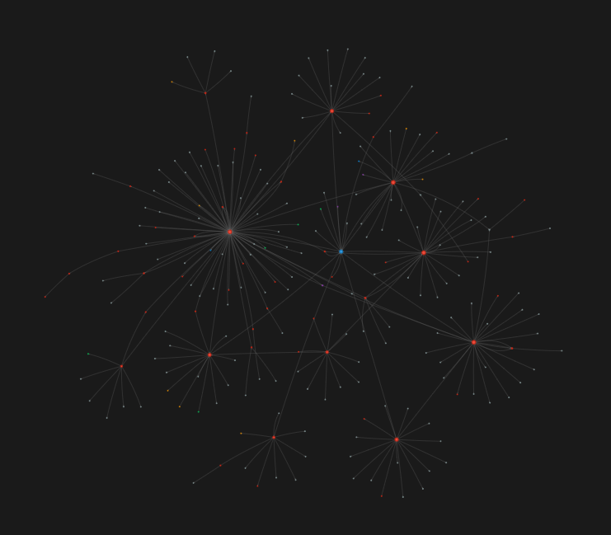
4 Evaluation
There will be two main parts of the project to evaluate our results. First and foremost, we determined our preferred method to extract logic triplets. We loaded our triplet results into a dataframe and compared them to each other. Right away, it was obvious which method would be preferable. The REBEL model produced approximately 800 triplets for filtering while the spaCy method produced around 1900. We performed more analysis and took samples of the triplets. From our observations, spaCy was clearly superior for this project.
After deciding on our method, we needed to perform extensive filtering to remove all the bad triplets. We loaded our triplets into a dataframe and utilized various exploratory data analysis techniques to remove all bad triplets. For example, we displayed all unique predicates and remove the ones that do not belong. Below is an example of some of the data analysis views we made to observe our data.
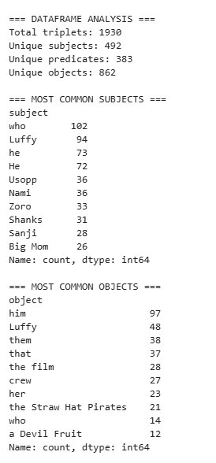Considering the intended scope of our project, we cannot simply verify the authenticity of every single logic statement created. Instead we resorted to these types of methods. Looking at the picture provided, we needed to deal with the cases where our subject or object are not important names/characters like “who.” Our extensive filtering architecture was how we evaluated the logic statements. Any triplet (S, P, O) that failed to make it through filtering will be removed. There is a chance that we remove too much data, but we value accuracy over quantity.
The other part of our evaluation was dealing with our visualization and queries. Even after our filtering, the initial knowledge graph had serious issues. 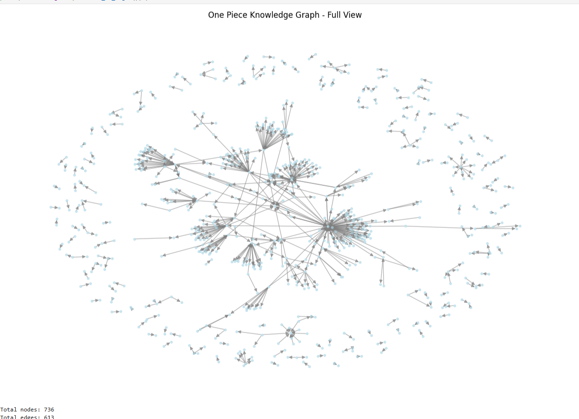
There were 171 communities: this means that the graph was very fragmented and disconnected. We performed PageRank analysis and found that there were weird nodes that were way more important than there should be. After this analysis, we had to run our triplets through another round of filtering.
5 Discussion
Our project has a maximum timeline of 4 weeks, based on the class duration of this summer session of the University of Colorado Boulder. Our deadlines are as follows: Week 1 is for research and scaffolding our project, Week 2 is for gathering our data. Week 3 is for extracting our logic statements, and Week 4 is for creating our data structure and our data visualization.
We must prepare for different circumstances or issues that could hinder our project. One of the chief concerns initially is the scope of our project. It may be too time consuming to process all of Wikipedia. In that case, we will focus on a subset of Wikipedia to work on our process before eventually upscaling our work to all of Wikipedia in the future.
After two weeks, we have already changed the scope of our project to dealing with a subset of Wikipedia instead of the entire body of text. Another major change is our decision to only extract subject, predicate, object logic triplets for analysis. Unfortunately, we underestimated the time it would take to create a robust extraction system.
We finalized what visualization method to use. The knowledge graph was a great way to represent our data and extract valuable insight.
Overall, the biggest issue we came across besides the amount of data was attempting to automate the process. We ended up having to create filtering methods specifically related to One Piece key words and phrases. Our original intention was to create a generalized method that created a knowledge graph for any subject the user entered, but that proves to be much more complicated than expected. I understand now why most expert systems are tailored to a very niche subject. Creating a generalized knowledge base for a generalized expert system seems very challenging.
6 Conclusion
This proposal involves automatically extracting logic statements from Wikipedia articles related to One Piece. The major components of this project are gathering our text data, conducting parsing to extract logic statements, and creating a storage system for visualizing and querying. We have successfully searched all of Wikipedia and obtained approximately 112 articles related to One Piece. We performed logic extraction using spaCy dependency parsing and obtained over 1900 logic triplets. After an extensive viewing and filtering process, we narrowed that count down to 613 triplets.
We loaded our triplets into a new file to convert them into an initial knowledge graph. After performing some analysis on the graph, we determined another round of filtering was needed. Finally, we created our improved knowledge graph and showcased examples of queries that can be run on it. I will provide an example of one query: 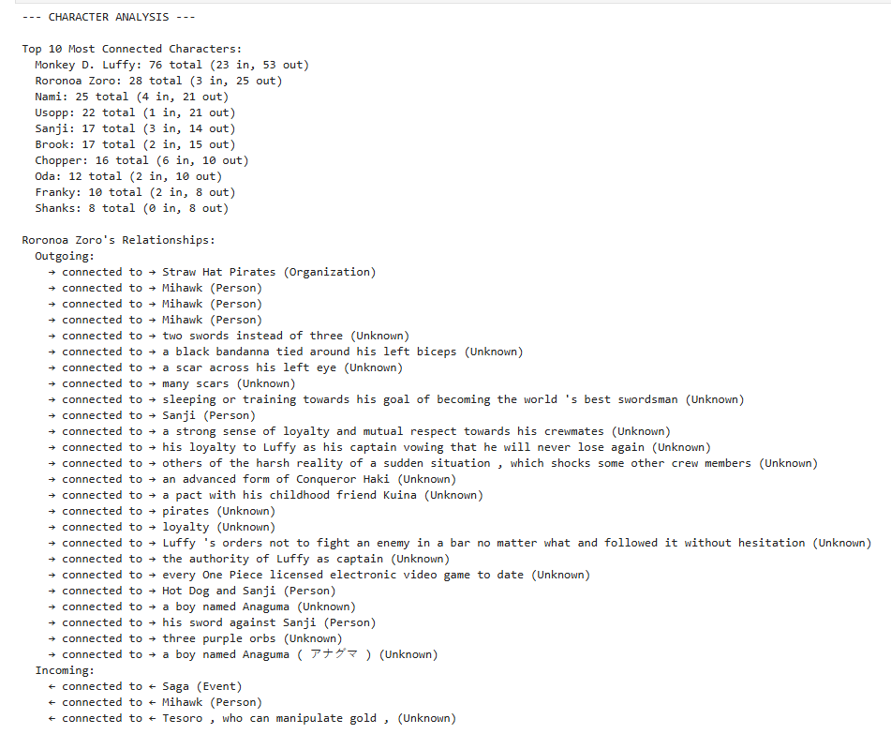

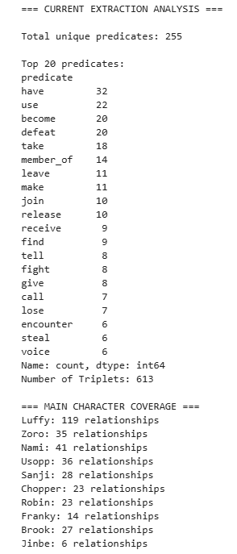
7 Future Work
Unfortunately, we were unable to complete our initial goal of parsing all of Wikipedia and obtaining logic statements from that. There are significant improvements that can be made to our current project. Mainly, we need to create a more robust way to get other logic statements that are in more complex forms than just subject, object, predicate. Alongside that, significant improvements can be made to the filtering methods used. More research should be conducted on how expert systems filter their knowledge database.
REFERENCES
https://spacy.io/usage/linguistic-features
https://huggingface.co/docs/transformers/en/index
https://www.mediawiki.org/wiki/API:Main_page

